Exercises for testing

This lecture is about testing your code, we will write tests for our code.

**Setting up our project**

Before we do this you will need to setup your environment.

1. Check that you have node installed in your environment

You can do this by running: node –v

If you get a response like the following you are ok you already have node.

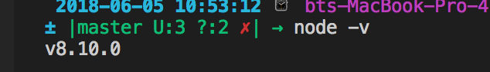

Otherwise you will need to download node and install it.

You can use this link <https://nodejs.org/en/>

Once you do this you are ready to go with our exercise

For each exercise create three different folders each time.

* Exercise-Mocha
* Exercise-Chai
* Exercise-Sinon

The structure of each folder will be the same for all.

* A **test folder** with a **tests.js** file
* And an **exercise.js** file

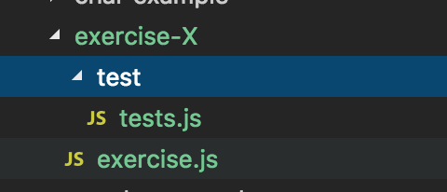

Navigate with command line to that folder

Type on the command prompt: **npm init**

**You will need to type the following (3 times for each one of the exercises)**

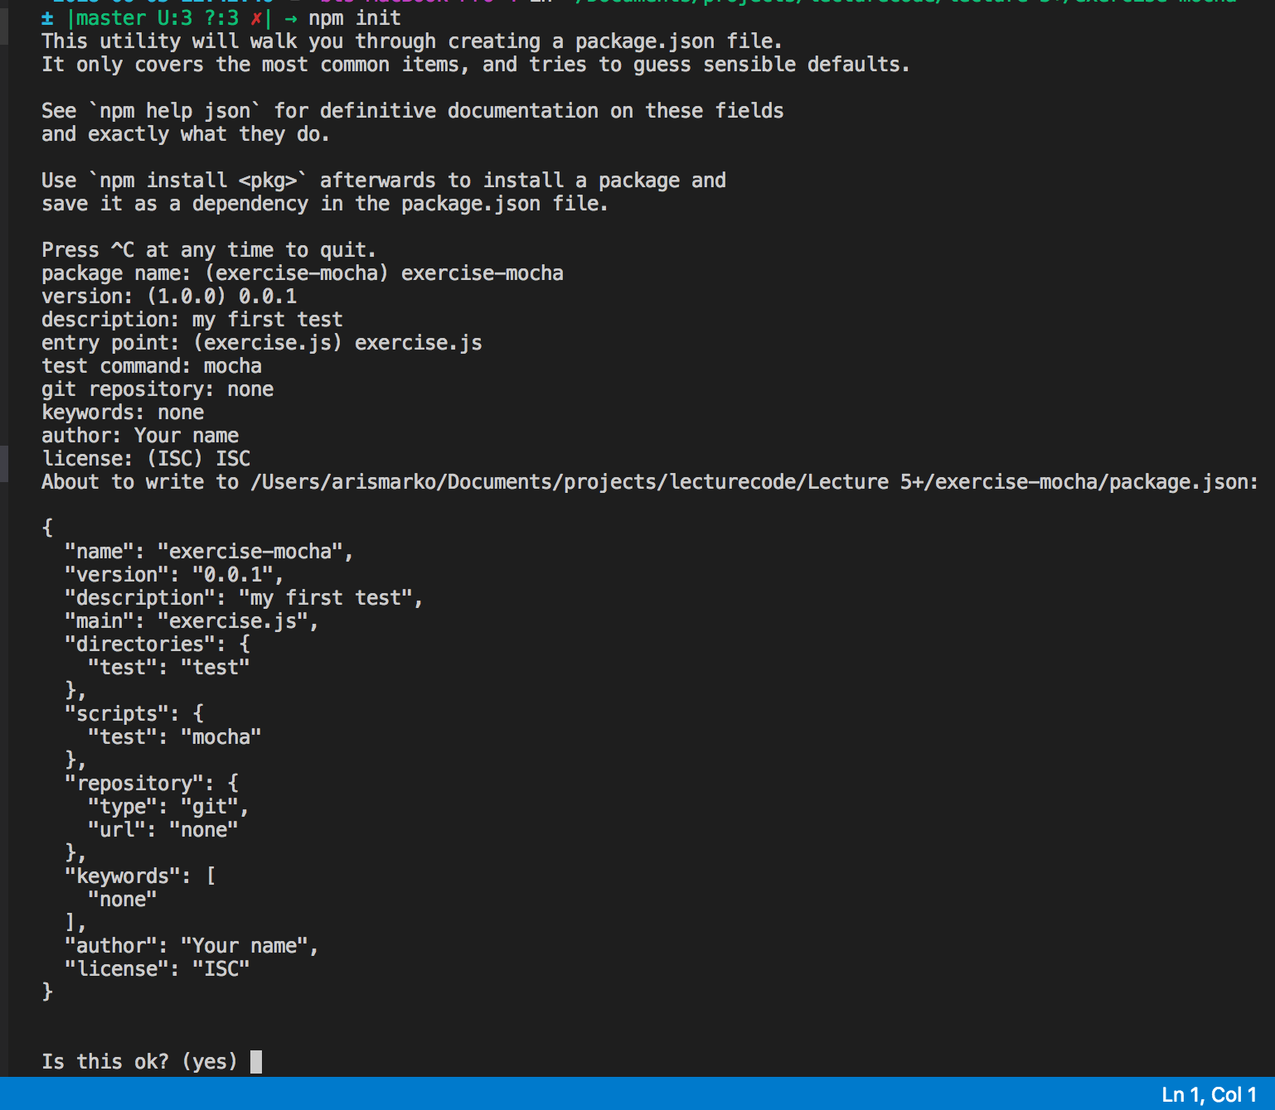

Press Enter that will create a **package.json** file.

Next we need to install mocha we will have to do the same for all three exercises

To do this run on the command line **npm install mocha –- save-dev**

(this command will add it to the development dependencies on your package.json)

**Exercise 1: Mocha**

For our first exercise we will use the Exercise.js The task is to build a function that we will take 2 inputs:

**Function bmi(height, weight) {**

**Var bmi =**

**return bmi;**

**}**

**The formula is:**

(weight (kilograms) / height (metres) )/ height (kilograms)

Our test should check for a person with the following characteristics

Weight: 90 kilos

Height: 1.90 metr

The formula should return **24.9**

**What we want to check if we pass 90 as weight and the 1.90 as height the result will be 24.9.**

**Write a mocha test that will check for this**

Step 1:

Inside the test.js add the following code: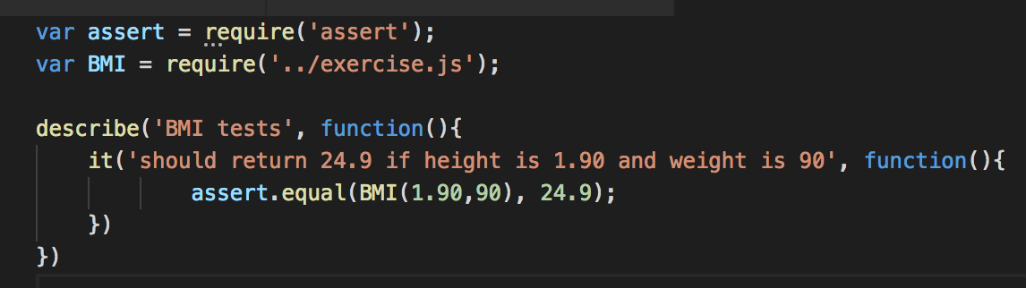

Step 2:

Inside the exercise.js write the following code

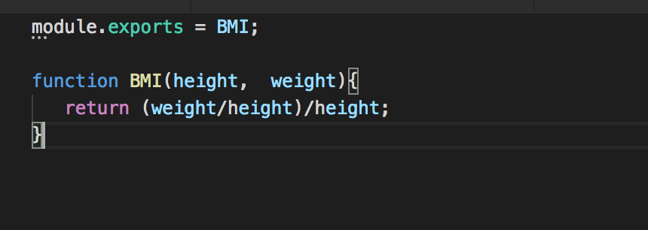

Step 3:

On your console run **npm run test**

What is the result of that? Did the test pass?

**Exercise 2: Chai**

For this exercise we will have to install chai

To do this in our command prompt (console) we will write the following command.

npm install chai --save-dev

Step 1:

;’Copy the code from the previous exercise to exercise.js



Step 2:

On your test will need to re-write it with chai

m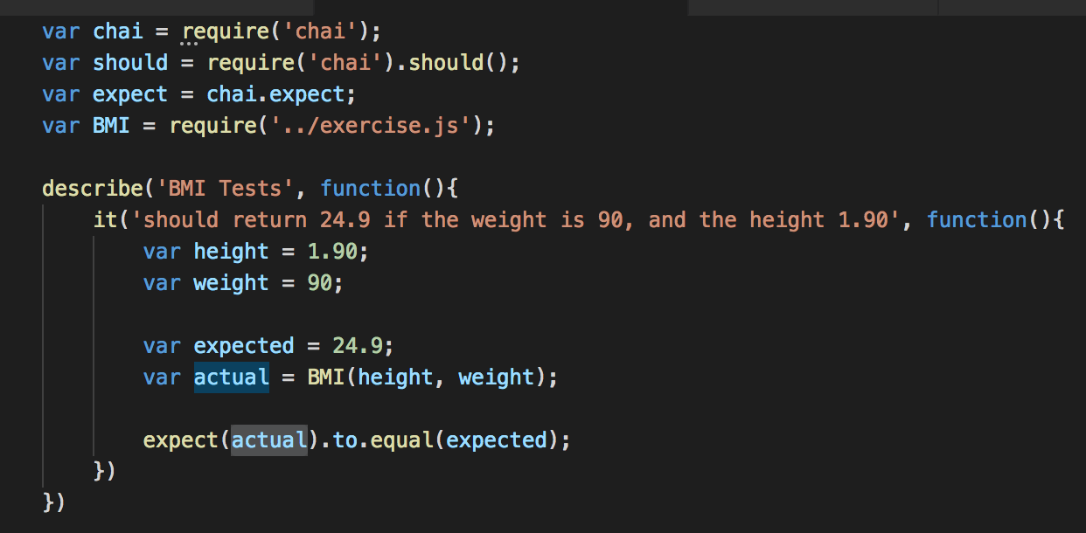

Step 3:

Run your test **npm run test**

What was the outcome?

**Exercise 3: Sinon**

For this exercise we will try the mock example of the Sinon

Before that we will need to create our folder and then install Sinon.

**npm install sinon --save-dev**

Step 1:

We want to know more this time so as we can see how many times the getsData method has been called on this userAccountsService

Rftrtg “

FASv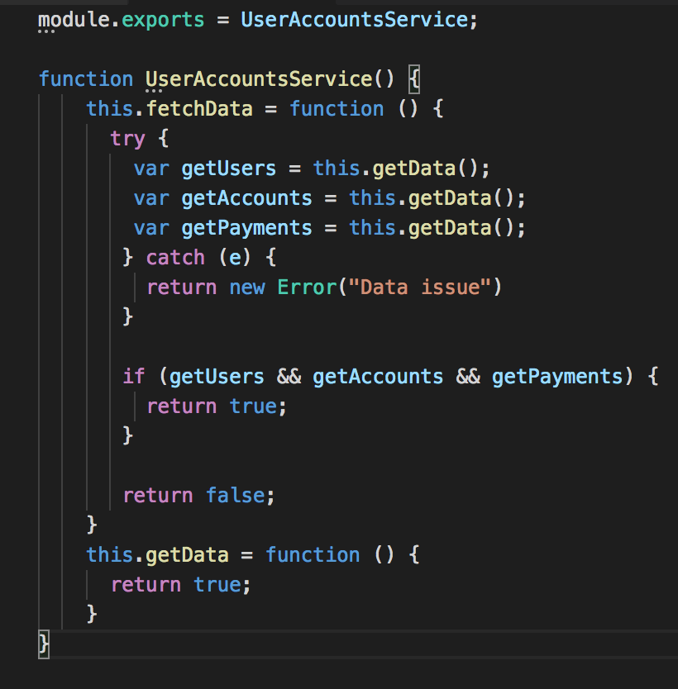

Step 2:

Now we need to write our code that will get the

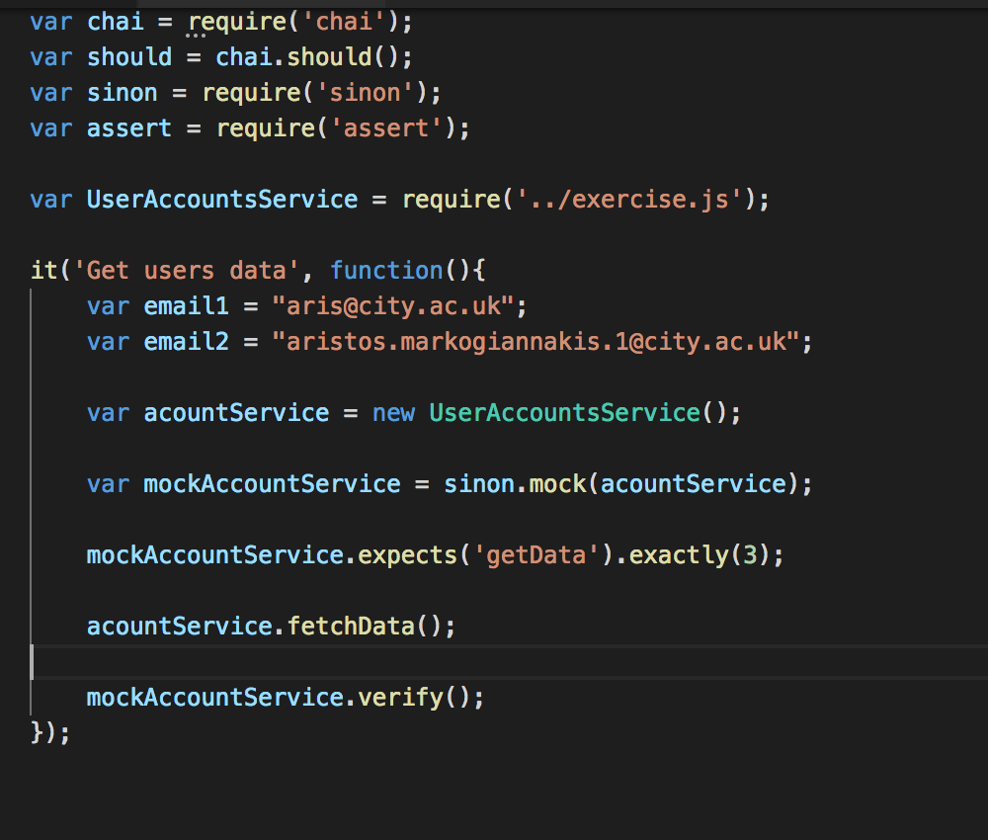

Step 3:

Execute your tests.